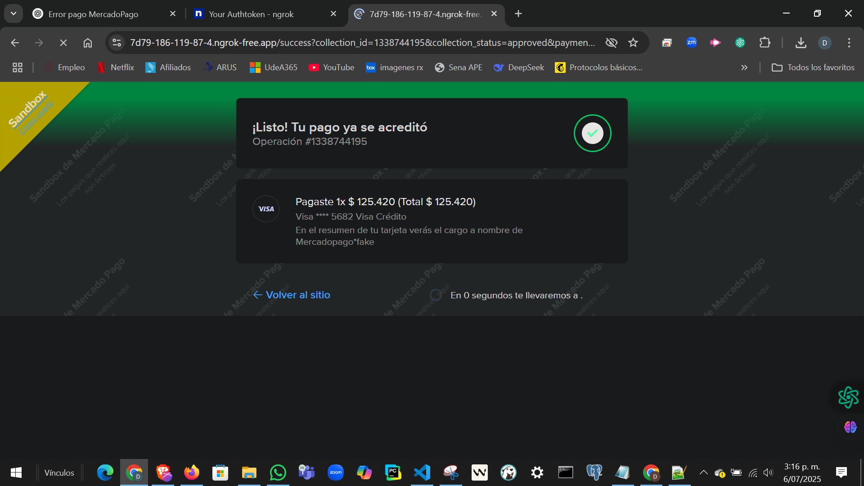

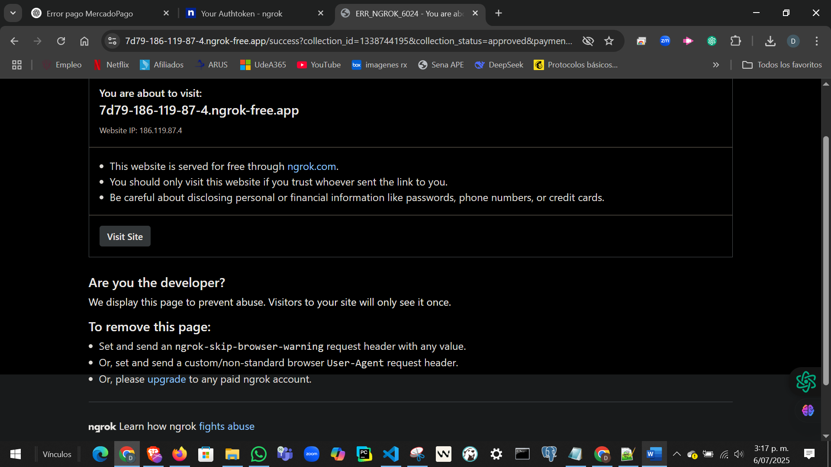

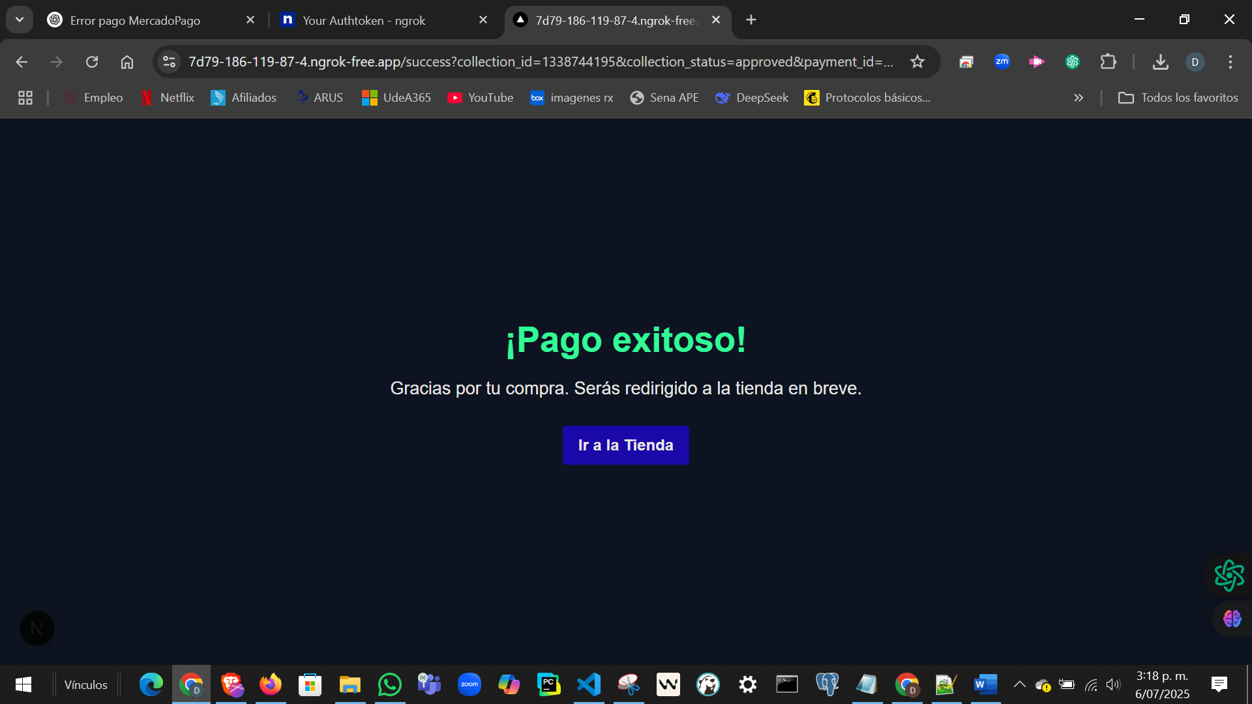

CREDENCIALES APLICACION VIRTUALTIENDA DE MERCADO PAGO

Public Key:TEST-09bbff3a-0f0f-4729-b07f-7776ad934bf3
Access Token:TEST-7430682771089046-070411-3735a7389faa3d7d14f339f2bc855a21-483755857

SELECT
o.id AS order_id,
o.total,
o.status,
o.created_at,
oi.id AS order_item_id,
oi.cantidad,
oi.precio_unitario,
p.id AS product_id,
p.nombre AS product_name,
p.descripcion,
p.precio,
p.imagen_url
FROM orders o
JOIN order_items oi ON o.id = oi.order_id
JOIN productos p ON oi.product_id = p.id
WHERE o.user_id = 'AQUÍ_EL_ID_DEL_USUARIO'
ORDER BY o.created_at DESC;

https://virtualTienda.com/api/mercadopago/webhook
clave secreta: bd6ac2f0d0e92009a18e6b988f2b1c366ddb62158378da293afcf77a80e41572

ngrok token
2zVwn22cc2Pd3mU3GXAr7rFlVo9_3ADFiV1bBoqiCvinaH6Yc
url publica
https://7d79-186-119-87-4.ngrok-free.app

tarjetas de prueba en mercadoPago:
visa:
Número: 4013 5406 8274 6260
Vencimiento: 11/30
CVV: 123
Titular: APRO.
Doc identificación: 123456789

inicializar ngrok:
ngrok http 3000
MER
